We use the following trapezoidal diagram below to grading of the participants experimental results. In the answers we will indicate parameters A,B, y and z for each experiment.

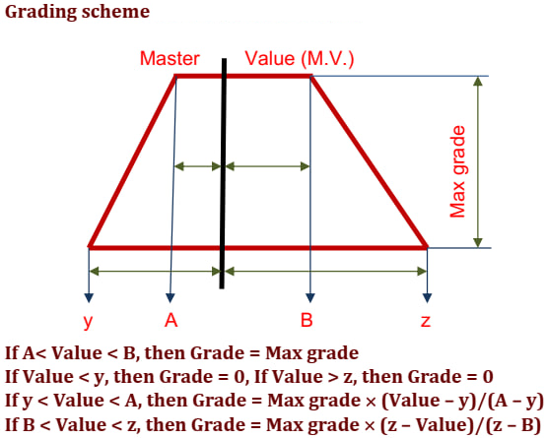

Problem 1 20% of 100 %
Question | 1.1.1 | 1.1.2 | 1.2.1 | 1.2.2 | 1.3.1 | 1.3.2 | Total
Points | 40 | 5 | 20 | 3 | 5 | 1 | 74
Result

To find the result of your student in experiments 1 to 9, your first need to find the master value using Table 1 and the temperature reported by your student. Next, you apply this master value to the trapezoid formulas also using the values of A, B, x, and y given in Table 2.
1.1.1.-1.2.1.-1.3.1. Master Values for experiments #1-9 in the temperature range 20-25°C:
Table 1
T, °C | t₁, s | t₂, s | t₃, s | t₄, s | t₅, s | t₆, s | t₇, s | t₈, s | t₉, s
21,0 | 361 | 168 | 169 | 87 | 225 | 168 | 123 | 101 | 135
21,1 | 359 | 167 | 168 | 87 | 224 | 167 | 122 | 101 | 135
21,2 | 356 | 166 | 168 | 86 | 222 | 166 | 122 | 100 | 134
21,3 | 354 | 165 | 167 | 86 | 221 | 164 | 121 | 100 | 134
21,4 | 351 | 164 | 166 | 85 | 220 | 163 | 121 | 100 | 133
21,5 | 348 | 163 | 166 | 85 | 219 | 162 | 121 | 99 | 133
21,6 | 346 | 162 | 165 | 84 | 217 | 161 | 120 | 99 | 132
21,7 | 343 | 161 | 164 | 84 | 216 | 159 | 120 | 99 | 132
21,8 | 340 | 160 | 163 | 83 | 215 | 158 | 119 | 98 | 131
21,9 | 338 | 159 | 163 | 83 | 214 | 157 | 119 | 98 | 131
22,0 | 335 | 158 | 162 | 82 | 212 | 156 | 119 | 98 | 130
22,1 | 333 | 157 | 161 | 82 | 211 | 154 | 118 | 97 | 130
22,2 | 330 | 157 | 160 | 81 | 210 | 153 | 118 | 97 | 129
22,3 | 327 | 156 | 160 | 81 | 209 | 152 | 117 | 97 | 128
22,4 | 325 | 155 | 159 | 80 | 208 | 151 | 117 | 96 | 128
22,5 | 322 | 154 | 158 | 80 | 206 | 149 | 116 | 96 | 127
22,6 | 320 | 153 | 158 | 79 | 205 | 148 | 116 | 96 | 127
22,7 | 317 | 152 | 157 | 79 | 204 | 147 | 116 | 95 | 126
22,8 | 314 | 151 | 156 | 78 | 203 | 146 | 115 | 95 | 126
22,9 | 312 | 150 | 155 | 78 | 201 | 145 | 115 | 95 | 125
23,0 | 309 | 149 | 155 | 77 | 200 | 143 | 114 | 94 | 125
23,1 | 306 | 148 | 154 | 77 | 199 | 142 | 114 | 94 | 124
23,2 | 304 | 147 | 153 | 76 | 198 | 141 | 114 | 93 | 124
23,3 | 301 | 146 | 152 | 76 | 196 | 140 | 113 | 93 | 123
23,4 | 299 | 145 | 152 | 75 | 195 | 138 | 113 | 93 | 123
23,5 | 296 | 144 | 151 | 75 | 194 | 137 | 112 | 92 | 122
23,6 | 293 | 143 | 150 | 74 | 193 | 136 | 112 | 92 | 121
23,7 | 291 | 142 | 150 | 74 | 192 | 135 | 112 | 92 | 121
23,8 | 288 | 141 | 149 | 73 | 190 | 133 | 111 | 91 | 120
23,9 | 286 | 140 | 148 | 73 | 189 | 132 | 111 | 91 | 120
24,0 | 283 | 139 | 147 | 72 | 188 | 131 | 110 | 91 | 119
24,1 | 280 | 138 | 147 | 72 | 187 | 130 | 110 | 90 | 119
24,2 | 278 | 137 | 146 | 71 | 185 | 128 | 109 | 90 | 118
24,3 | 275 | 136 | 145 | 71 | 184 | 127 | 109 | 90 | 118
24,4 | 272 | 135 | 144 | 70 | 183 | 126 | 109 | 89 | 117
24,5 | 270 | 134 | 144 | 70 | 182 | 125 | 108 | 89 | 117
24,6 | 267 | 133 | 143 | 69 | 180 | 123 | 108 | 89 | 116
24,7 | 265 | 133 | 142 | 69 | 179 | 122 | 107 | 88 | 116
24,8 | 262 | 132 | 142 | 68 | 178 | 121 | 107 | 88 | 115
24,9 | 259 | 131 | 141 | 68 | 177 | 120 | 107 | 88 | 114
25,0 | 257 | 130 | 140 | 67 | 176 | 119 | 106 | 87 | 114

For each experiment #1-4 Max Grade 10 points.
For each experiment #5-9 Max Grade 5 points.
Table 2
# Experiment | A, s | B, s | y, s | z, s
1 | -7 | +7 | -14 | +14
2 | -5 | +5 | -10 | +10
3 | -5 | +5 | -10 | +10
4 | -3 | +3 | -6 | +6
5 | -10 | +10 | -20 | +20
6 | -7 | +7 | -14 | +14
7 | -5 | +5 | -10 | +10
8 | -3 | +3 | -6 | +6
9 | -3 | +3 | -6 | +6

1.1.2.
x = _________1___________ | y = _________1___________
z = _________2___________ | k (at 25°C) = ______44.5 M⁻³ s⁻¹______

For each correct calculation of x, y, z and k 1 point.
For correct unit of k 1 point.
1.2.2.
Experiment  # | r_{cat} (at 25°C), M·s⁻¹ | [Mo^{VI}], M
5 | 1.89·10⁻⁷ | 1.0·10⁻⁵
6 | 2.80·10⁻⁷ | 2.0·10⁻⁵
7 | 3.14·10⁻⁷ | 3.0·10⁻⁵
8 | 3.83·10⁻⁷ | 4.0·10⁻⁵

For each r_{cat} and [Mo^{VI}] value calculation 0.25 points.
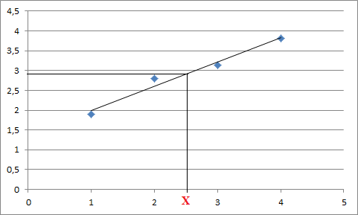
For a correctly drawn graph 1 point.
1.3.2.
r_{catX} (at 25°C) = 2.92·10⁻⁷ M·s⁻¹
2.5·10⁻⁵ = $\frac{{10C}_{{Mo}^{VI}}}{50}$
$C_{{Mo}^{VI}}$ (at 25°C) = __________1.25·10⁻⁴___________ M

For correct calculation of $C_{{Mo}^{VI}}$ 1 point.

Problem 2 20% of 100 %
Question | 2.1.1 | 2.1.2 | 2.2.1 | 2.2.2 | 2.2.3 | 2.2.4 | 2.2.5 | 2.3.1 | 2.3.2 | 2.3.3 | 2.3.4 | 2.3.5 | 2.3.6 | 2.3.7 | Total
Points | 10 | 1 | 0 | 10 | 1 | 3 | 2 | 0 | 2 | 4 | 0 | 10 | 6 | 2 | 51
Result

2.1.1.
$V_{1}=9.90 mL$
A, mL | B, mL | y, mL | z, mL
-0.15 | +0.15 | -0.30 | +0.30

For volume $V_{1}$ Max Grade 10 points.
2.1.2.
C_{HA,1} = ________0.099___________ M

For correct calculation of C_{HA,1} 1 point.
2.2.1.
0 point
2.2.2.
$V_{2}=2.05 mL$
A, mL | B, mL | y, mL | z, mL
-0.05 | +0.05 | -0.25 | +0.25

For volume $V_{2}$ Max Grade 10 points.
2.2.3.
C_{HA,2} = _________0.1025__________ M

For correct calculation of C_{HA,2} 1 point.
2.2.4.
pH = ________4.51-4.91_________ | pK_{a}(HA) = _______4.51-4.91__________

For pH measure 2 points, if the value is in the specified region.
For pK_{a}(HA) = pH 1 point.
2.2.5.
M_{HA} = _______58,5-60,6________ g/mol | HA: _________CH₃COOH___________

For calculation of M_{HA} 1 point.
For determination of the HA 1 point.
2.3.1.
0 point
2.3.2.
$N_{H^{+}}$ = ________2________

For only answer “$N_{H^{+}}=2$” 2 points.
2.3.3.
$${2 mL<V}_{a3}≤3 mL$$
$${5 mL<V}_{a4}≤6 mL$$
Only for the volumes $V_{a3}$ and $V_{a4}$ inside the specified regions 2 points each.

2.3.4.
0 point
2.3.5.
$V_{e3}=2.55 mL$
$V_{e4}=5.25 mL$

 | A, mL | B, mL | y, mL | z, mL
For $V_{e3}$ | -0.05 | +0.05 | -0.25 | +0.25
For $V_{e4}$ | -0.05 | +0.05 | -0.25 | +0.25

For each volume $V_{e3}$ and $V_{e4}$ Max Grade 5 points each.
2.3.6.
pH₁ = ________2.65-3.05________ | pK_{a1}(H_{n}B) = ________2.65-3.05_________
pH₂ = ________6.86-7.26_________ | pK_{a2}(H_{n}B) = ________6.86-7.26_________

For each pH measure 2 points, if the value is in the specified region.
For each pK_{a}(H_{n}B) 1 point.
2.3.7.
$M_{H_{n}B}$ = _______93.3-96.1________ g/mol | H_{n}B: ________H₃PO₄____________

For calculation of $M_{H_{n}B}$ 1 point.
For determination of the H_{n}B 1 point.

