Problem 1 7.5 of 100 %
Question | 1.1 | 1.2 | 1.3 | 1.4 | 1.5 | 1.6 | 1.7 | 1.8 | Total
Points | 18 | 8 | 4 | 4 | 6 | 12 | 3 | 8 | 63
Result

  - (18 pt.)

A: _____________ B: _____________

C: _____________ D: _____________

E: _____________ X: _____________

  - (8 pt.)

  - (4 pt.)

[ ] SC [ ] BCC [ ] FCC

  - (4 pt.)

$r\left(X\right)=_____________$

  - (6 pt.)

E: _____________

  - (12 pt.)
E (6 pt.) | F (6 pt.)

  - (3 pt.)

G: _____________

  - (8 pt.)

a) (2 pt.):

b) H (6 pt.)

Problem 2 7.5 of 100 %
Question | 2.1 | 2.2 | 2.3 | 2.4 | 2.5 | 2.6 | 2.7 | 2.8 | Total
Points | 2 | 3 | 2 | 1 | 4 | 3 | 2 | 6 | 23
Result

  - (2 pt.)

  - (3 pt.)

A = _____________________

  - (2 pt.)
1850-1900 ______
1900-1950 ______
  - ______

  - (1 pt.)
⁸⁷Rb picture ______
- ⁸⁷Sr picture ______
- ⁸⁶Sr picture ______

  - (4 pt.)

t = _____________________.

  - (3 pt.)

$\frac{N_{0}\left({}_{}^{87}{Sr}\right)}{N\left({}_{}^{86}{Sr}\right)}=$ ____________________ (s1, s2)
$\frac{N_{0}\left({}_{}^{87}{Rb}\right)}{N({}_{}^{86}{Sr)}}=___________________________$ (s 1)
$\frac{N_{0}\left({}_{}^{87}{Rb}\right)}{N({}_{}^{86}{Sr)}}=___________________________$ (s 2)

  - (2 pt.)

- ²³⁵U ___________________
- ²³⁸U ___________________

  - (6 pt.)

(a) 3.0⸱10⁹ | (b) 3.5⸱10⁹ | (c) 4.0⸱10⁹ | (d) 4.5⸱10⁹ | (e) 5.0⸱10⁹ | (f) 5.5⸱10⁹ | (g) 6.0⸱10⁹

Problem 3 7.5 of 100 %
Question | 3.1 | 3.2 | 3.3 | 3.4 | 3.5 | 3.6 | 3.7 | 3.8 | 3.9 | Total
Points | 5 | 6 | 12 | 2 | 6 | 6 | 6 | 6 | 23 | 72
Result

3.1. (5 pt.)
a) (1 pt.)
b) (4 pt.)
i)
ii)
iii)
iv)

3.2. (6 pt.)
A (3 pt.) | B (3 pt.)

3.3. (12 pt.)
I-1 (4 pt.) | I-2 (4 pt.) | C (4 pt.)

3.4. (2 pt.)

D.U. = ______________

3.5. (6 pt.)
Fragment 1

3.6. (6 pt.)
Fragment 2

3.7. (6 pt.)
E

3.8. (6 pt)
G

3.9. (23 pt.)
H (3 pt.) | I (3 pt.) |  | 4 (3 pt.)
K (3 pt.) |  | K (3 pt.)
L (4 pt.) |  | M (4 pt.)

Problem 4 7.5 of 100 %
Question | 4.1 | 4.2 | 4.3 | 4.4 | 4.5 | 4.6 | 4.7 | 4.8 | 4.9 | Total
Points | 2 | 2 | 4 | 2 | 1 | 2 | 1 | 3 | 6 | 23
Result

  - (2 pt.)

a)

b)

  - (2 pt.)

Е°₁ = _________________ | Е°₂ = __________________

  - (4 pt.)
a)

☐ Y | ☐ N

b)

☐ Y | ☐ N

  - (2 pt.)
a)

$E_{As/AsH_{3}}$ = _____________________________

b)

$E_{As/AsH_{3}}$(pH = 14) = __________________

  - (1 pt.)

pK_{a}(Н₃AsO₃) = ___________________

  - (2 pt.)

pH ___________________

  - (1 pt.)

Y: __________________

  - (3 pt.)

Х: __________________

a)

b)

  - (6 pt.)

a)

b)

K = _______________________

Problem 5 7.5 of 100 %
Question | 5.1 | 5.2 | 5.3 | 5.4 | 5.5 | 5.6 | 5.7 | 5.8 | 5.9 | Total
Points | 6 | 4 | 3 | 2 | 4 | 4 | 6 | 2 | 2 | 33
Result

  - (6 pt.)
- (4 pt.)

T=$__________$
- (2 pt.)

$p=__________$

  - (4 pt.)

T =$__________$

  - (3 pt.)

$γ\left(T,RH\right)=__________$

$T_{d}=__________$
Y N

  - (2 pt.)
a)

Y N

b)

R S

  - (4 pt.)

  - (4 pt.)

$$∆S=__________$$

  - (6 pt.)


$$k=__________$$

  - (2 pt.)

$$l_{1960}=__________$$

  - (2 pt.)

$$________________$$

Problem 6 7.5 of 100 %
Question | 6.1 | 6.2 | 6.3 | 6.4 | 6.5 | 6.6 | 6.7 | 6.8 | Total
Points | 1.5 | 0.5 | 5 | 3 | 4 | 0.5 | 1.5 | 2 | 18
Result

6.1. (1.5 pt.)
a) (0.5 pt.)

__________

b) (0.5 pt.)
Y N
c) (0.5 pt.)
__________

6.2. (0.5 pt.)

6.3. (5 pt.)
a) (3 pt.)

__________

b) (1 pt.)
Y N

c) (1 pt.)

AA __________ OP __________

  - (3 pt.)

__________________________________________

  - (4 pt.)
X (1 pt.) | Y (1.5 pt.)
Z (1.5 pt.)

6.6. (0.5 pt)

_________________

6.7. (1.5 pt.)

6.8. (2 pt.)

__________________________________

Problem 7 7.5 of 100 %
Question | 7.1 | 7.2 | 7.3 | 7.4 | 7.5 | 7.6 | Total
Points | 14 | 5 | 4 | 17 | 8 | 12 | 59
Result

  - (14 pt.)

X = _____________________________________

1) ______________________________________

2) ______________________________________

  - (5 pt.)

T = _______

  - (4 pt.)

∆V/V = _______

  - (17 pt.)

a = _________ r = __________

  - (8 pt.)

t = _______

  - (12 pt.)

Y – _________ Z – _________

 | Problem 8 7.5 of 100 %
Question |  | 8.1 | 8.2 | 8.3 | 8.4 | 8.5 | 8.6 | 8.7 | 8.8 | 8.9 | Total
Points |  | 32 | 8 | 8 | 8 | 8 | 4 | 4 | 12 | 16 | 100
Result

  - (32 pt.)
A | E
B | F
C | G
D | X

  - (8 pt.)
C.N.= _____________

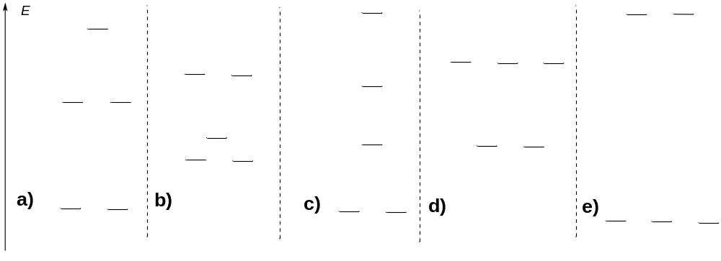

  - (8 pt.)
a) (4pt.):
H

b) (4 pt.):

  - (8 pt.)
a) (4 pt.)
Z

b) (4 pt.):

  - (8 pt.)

N = _____________
  - (4 pt.)

  - (4 pt.)

  - (12 pt.)
I:

J:

I₁:

  - (16 pt.)
K₁:

K₂:

